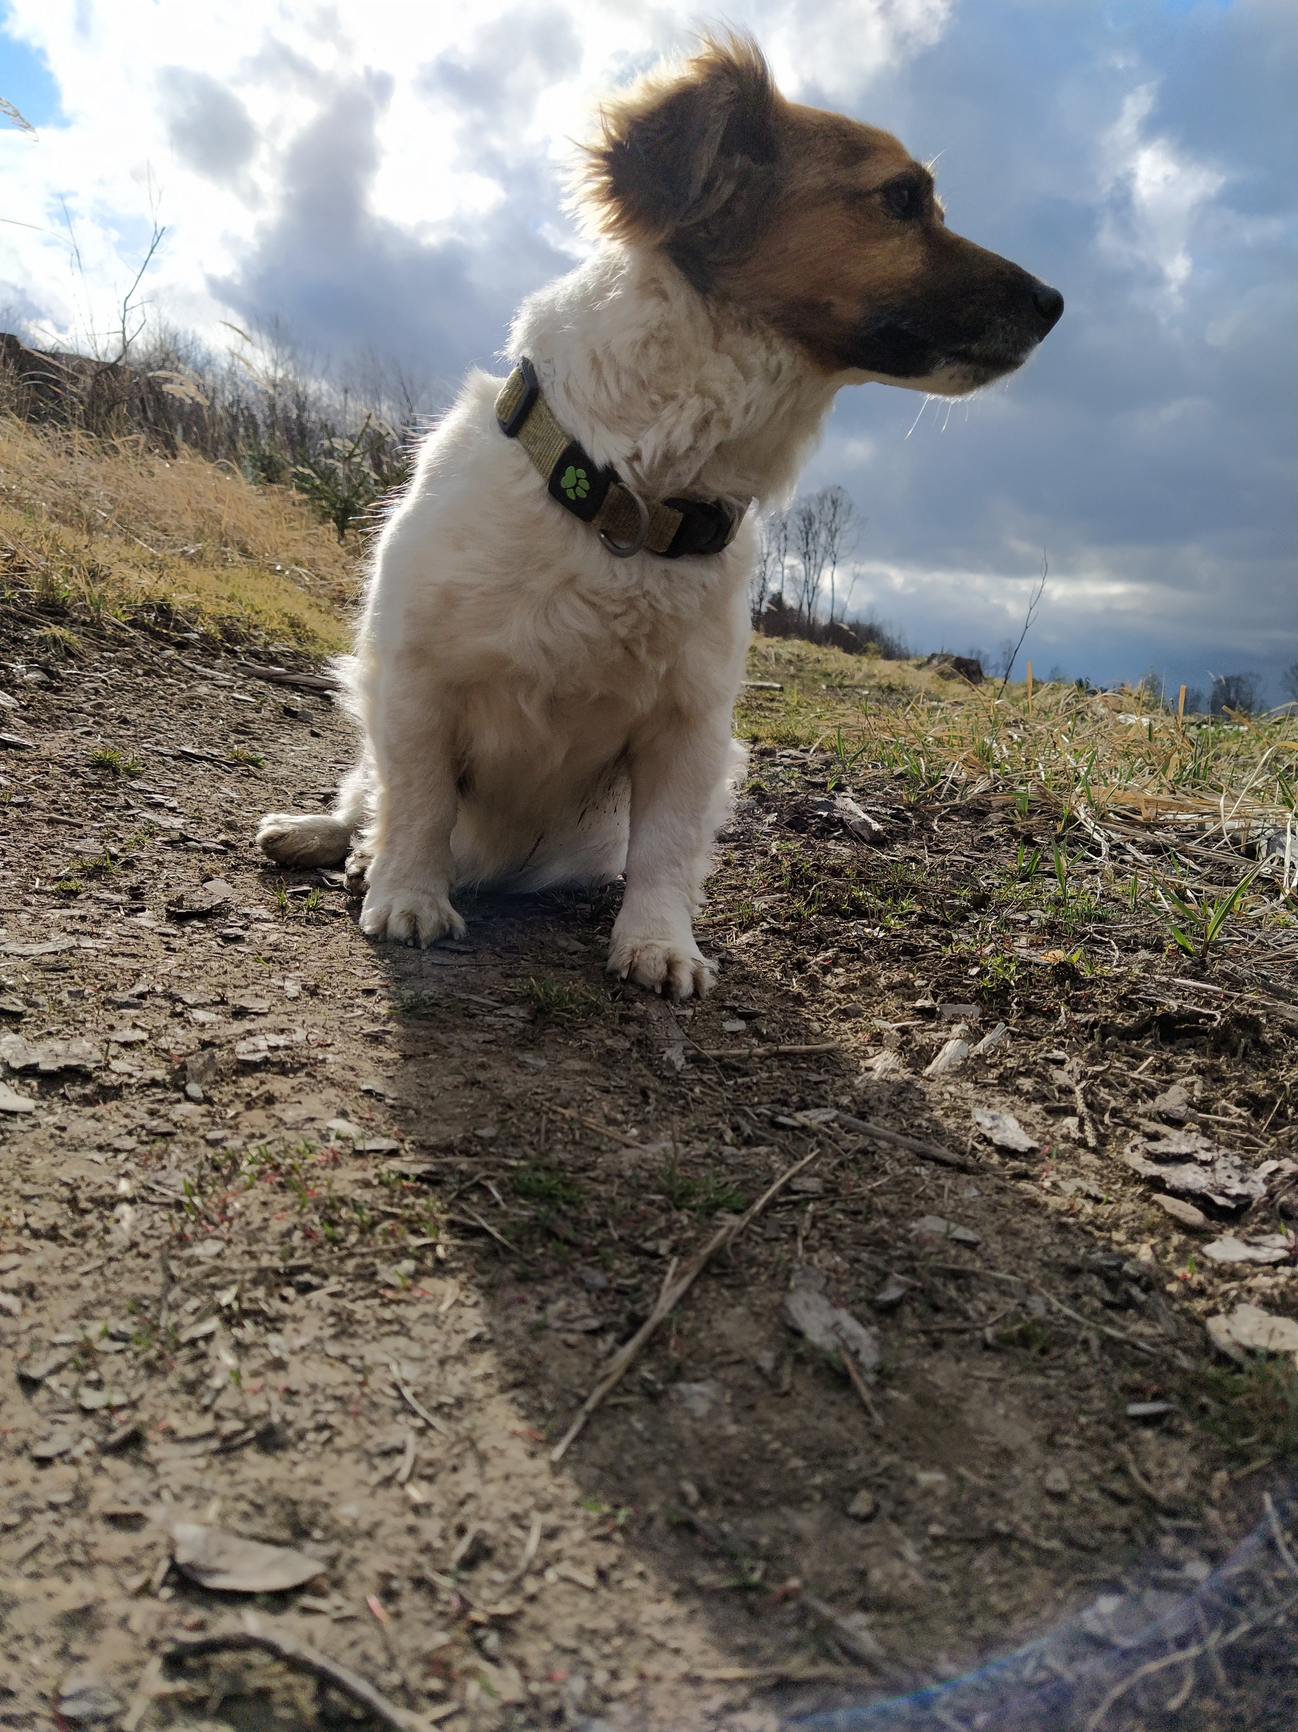

|  |  |  |
| --- | --- | --- |
| P E S | | |
|  |  |  |

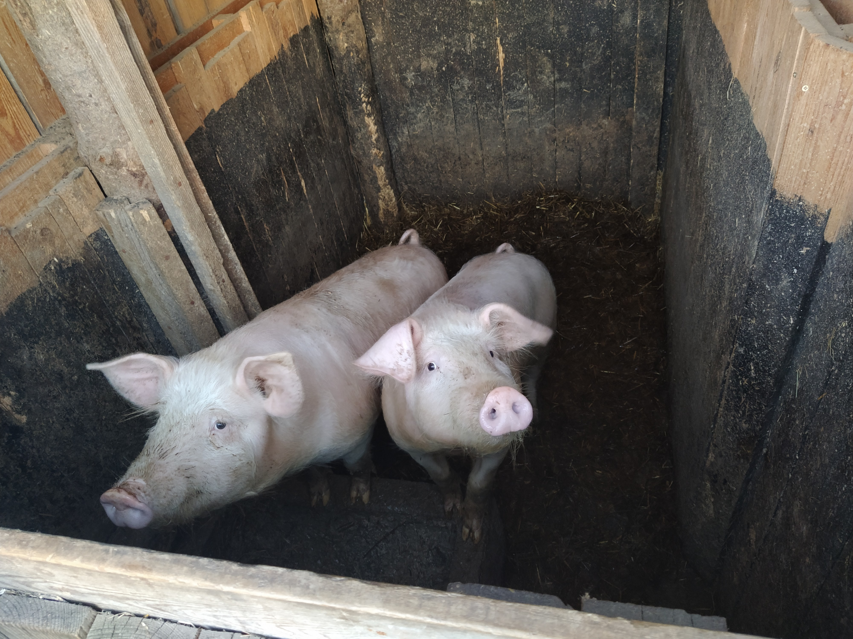

|  |  |  |  |  |
| --- | --- | --- | --- | --- |
| P R A S E | | | | |
|  |  |  |  |  |